Hypothesis for Testing Regional Real Estate Company
Your name
Southern New Hampshire University

Introduction
I am going to demonstrate how to analyze real estate data, employ statistical techniques in addressing real estate data performance hypothesis testing, for Real Estate companies and also address an authentic result. Specifically, this will involve setting up competing hypotheses, selecting a random sample from the population of interest, and computing summary statistics. Again, I will also determine whether the sample data support the null or supports the alternative hypotheses.
Set up
In the set-up I will use a 1001 sample data cost per square foot price in Pacific region in USA.
Test statistics -8994
Sample mean $264,020

Target 310,000
Standard error 5,110

Standard statistics
Sample size 1000

Sample mean $264,020

Sample median $202,070
Sample standard deviation 161,76
In this case, you will be required to write the null and alternative hypotheses. The salesperson believes that his sales are higher.
Left Tailed Test
H:u=310
H1:u<310
Right Tailed Test
H0:=310

H1:u >310
Two Tailed Test
H0:u =310
H1: u not = 310

Basically, after computing my sample mean I don’t need to calculate two-tailed tests. The salesperson's average home sales cost per cost square foot will be $310.The sample average home sales cost per square foot will be $264.
The right-tailed test will be the best to go for because, after the histogram graphic of the sample data, the results produced gave an idea about a critical region and critical value that lays on the right-tailed model. The right-tailed model occasionally appears as an upper test where the hypothesis statement contains a greater statement than the symbols. The inequality points to be right. Again, One-tailed tests contain more statistical power to sense an effect in one direction than a two-tailed test done with the same design and significance level. One-tailed tests occur most of the time in studies where the effects exist only in one direction. In this case, the effect is in the right direction
Data Analysis Preparation
The data sample provided is 1001 houses cost per square foot price in the pacific region in USA. Random selection method is employed to create the sample.
Sample statistics  Sample size  Sample mean  Sample median  Sample standard deviation  Standard error  T Value | 1001  $264,020  $202,970  $161,760  $5.11  -8.994

Minimum 103,832,378

Maximum | 107128397
Sum  count | 264280409  1001
Confidence levels (95, 0%) | 10,0327218

A Histogram of the sample

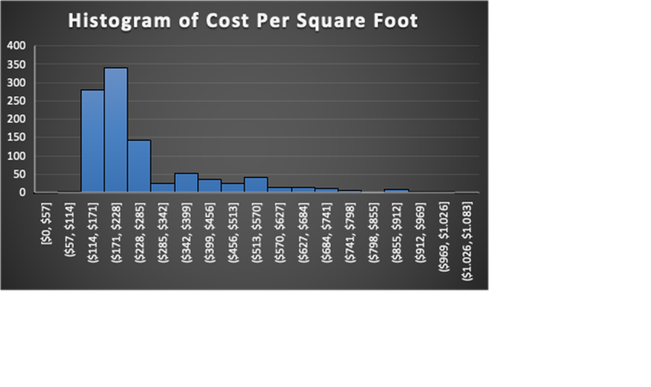
From the histogram graphic representation of the sample data shown above, it is a chi-square distribution. The Tail goes off the right. The mean is a little bit higher than the median. The mean will be a direction of a squab. Cost per square foot price less than $310/per square foot price. From this graphic representation, normality can be assumed. When the data sample is put in a scatter plot chart, positive linear regression is achieved. Between the cost of square foot price and house listing price in a pacific region. The significance level is the probability of rejecting the null hypothesis when it is true. A significance level of 0.05 shows a 5% risk of concluding that a difference exists where no actual difference .on the other hand, lower significance levels indicate that one needs stronger evidence before rejects the null hypothesis.
Significance level = a =.05.

Two Tailed Test
HO:U = 310
H1 : U not =310
Test statistics | -8,994
Sample mean | 264,02
Target | 310,00
Standard Error | 5,11
Upper Tailed Test /Right Tailed Test

H0:u =310
H1:u > 310
Test statistics | -8,994
Sample mean | 264,02
Target | 310,00
Standard Error / square root of n | 5,11
Left Tailed Test
H0:U=310
H1: U <310
Test statistics | -8,994
Sample mean | $264,02
Target | 310,00
Standard Error | 5,11
Calculations for the value of p can be done using the following test
=T.DIST.RT (test statistic), (degree of freedom})
In a two-tailed test where the p-value is less than the significant level 0.05, the null hypothesis is rejected. In an upper tailed test, where the p-value is 1.00 greater than the significance level of 0.05, the null hypothesis is not rejected. This means that the cost per square foot in the pacific region is definitely not above $ 310 /per square foot. The left Tailed test indicates a p-value less than the significance level whereby the null hypothesis is rejected. This evidence shows that the population means is less than $ 310 /square foot.
Test decision
Two tests are not very suitable for the sample data analysis. When summed up, the value of p in the two tests is less than the significance value hence the null hypothesis is rejected in this case. Sufficient evidence exists which shows that the mean cost per square foot in the pacific region is not equal to $ 310/ per square foot. Again the left tailed test the null hypothesis is rejected based on the true option. In the right tailed test, the significance value is less than the value of p which is 1.00 therefore the null hypothesis is not rejected.

Conclusion
In comparison, sample p-value in the data sample provided, if the p-value is less than any sample significance level, the null hypothesis will be rejected thus the effect will be statistically significant. In case the right-tailed test is true for the data sample I provided, the right-tailed test of my sample p-value will be greater than the significance value which means that insufficient evidence exists than the mean. The correct test should be the Left Tailed Test because based on the left tailed test, the p-value is less than the significance value level 0.05 which shows that the mean salesperson's claim is true. The average home sale cost per foot price is under $310.This statistical analysis in my sample has strong and enough evidence to statistically prove significant for data analysis in real estate companies.

